User Guide 16 Amending a Planning Permit Application
Purpose of this User Guide
The purpose of this User Guide is to provide advice to users wishing to modify an active SPEAR application.
Who should read this?
Primary audience: Applicant and Responsible Authorities
For information: Referral Authorities
Introduction
An applicant may need to modify an application that their organisation has created. The application must be ‘current’, which means that the planning process has not yet been completed.
There are two types of planning application:
- Planning permit only application
- Planning permit & certification application (or ‘Joint’ application)
A planning permit application consists of:
- Form data that was previously supplied using the Create Application wizard in SPEAR (i.e. the application form)
- Supporting documents which have previously been loaded into the application (i.e. plans and/or documents)
If there is a need to amend a planning permit which has already been issued, please refer to User Guide 7 - Application to amend planning permit.
16.1 Changing application form data
Up until a permit has been issued, an application can be amended. To do this, the applicant selects the ‘Modify’ option alongside the reference to the application details on the Details screen and clicks ‘go’ .

The Applicant Contact can now add and/or modify supporting documents as normal and submit the application.
16.2 Assessing changes to form data after lodgement with the Responsible Authority
After the applicant has requested a change to information within their application, the Responsible Authority will receive a notification. The Responsible Authority is then required to respond to this proposal by selecting the mandatory action on the Details tab as shown below:
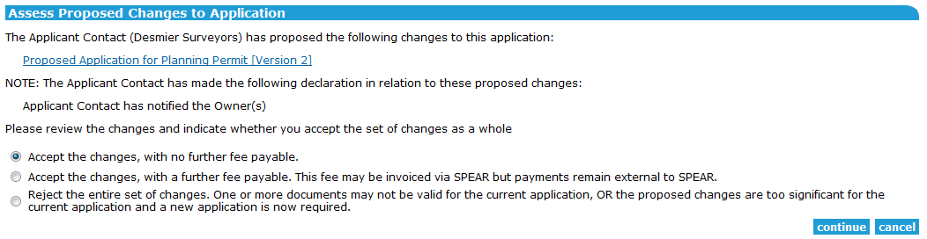
This action takes the Responsible Authority to the following screen where they can select to ‘Accept’ or ‘Reject’ the application to amend planning permit.
16.3 Changing supporting documents
Applicants can add new versions of documents at any time whilst an application is current including:
New versions of documents which have already been added to the application, and
New documents which have not yet been added to the application.
Once the applicant has authenticated each modified or new document, they are required to make the mandatory action ‘Submit All Proposed Changes To Responsible Authority’ which will notify the Responsible Authority. See User Guide 16 for detailed instructions on modifying and adding new documents.
The Responsible Authority will view the new or modified documents, with the description of the change that the applicant has entered.
If the Responsible Authority determines that the new version or new documents are unacceptable in the context of the application, the Responsible Authority is then required to reject the proposed change. In this case, the proposed documents submitted by the applicant are stored as ‘rejected’ versions.
If the Responsible Authority accepts the new documents or versions of documents, council accepts the proposed change, and SPEAR adds mandatory actions to re-check advertising and referral requirements. See User Guide 16 for details instructions on processing proposed changes.
16.4 Referring and advertising an amended permit application
A Responsible Authority may choose to re-advertise and/or re-refer an amended application. See User Guide 4 Advertising and User Guide 3 Referrals.
Need more information?
Further information on this topic can be found by:
- Visiting the SPEAR website www.spear.land.vic.gov.au/SPEAR
- Contacting the SPEAR Service Desk on 9194 0612 or email spear.info@delwp.vic.gov.au
- Selecting the Help link in the relevant area of the SPEAR system
- To obtain a Planning Property Report or for information on Planning Schemes, visit: Planning - Planning
- For information on Titles, visit www.land.vic.gov.au

